***Project Phase III Report***

***On­­­***

**Shopping website for Clothes and Fashion (E-Commerce Website)**

**Submitted for the requirement of**

**Project course**

BACHELOR OF ENGINEERING

**COMPUTER SCIENCE & ENGINEERING**



**Submitted to: Submitted by:**

Ms. Deepika **Leader: Neeraj Chandwani :** 20BCS2434  **Project Teacher (Supervisor) Abharan Singh Andotra** : 20BCS2438 **(Er. Deepika & Ecode- 11809)** **Harjeet Singh Thakral:** 20BCS2451 **Hardik Dhamija:** 20BCS2446  **Vaasav Bhadwal :** 20BCS2534



**DEPARTMENT OF COMPUTER SCIENCE & ENGINEERING**

**CHANDIGARH UNIVERSITY, GHARUAN**

**June 2022**

### 

**ABSTRACT**

In day to day life, we will need to buy lots of goods or products from a shop. It may be food items, electronic items, house hold items etc etc. Now a days, it is really hard to get some time to go out and get them by ourselves due to busy life style or lots of works. In order to solve this, B2C E-Commerce websites have been started. Using these websites, we can buy goods or products online just by visiting the website and ordering the item online by making payments online.

This existing system of buying goods has several disadvantages. It requires lots of time to travel to the particular shop to buy the goods. Since everyone is leading busy life now a days, time means a lot to everyone. Also there are expenses for travelling from house to shop. More over the shop from where we would like to buy some thing may not be open 24*7*365. Hence we have to adjust our time with the shopkeeper’s time or vendor’s time.

In order to overcome these, we have e-commerce solution, i.e one place where we can get all required goods/products online. The proposed system helps in building a website to buy, sell products or goods online using internet connection. Purchasing of goods online, user can choose different products based on categories , online payments , delivery services and hence covering the disadvantages of the existing system and making the buying easier and helping the vendors to reach wider market.

**TABLE OF CONTENT**

|  |  |  |
| --- | --- | --- |
| Sr no. | Topic | Page No. |
| 1 | Feature/characteristics identification | 4 |
| 2 | Constraints Identification | 4 |
| 3 | Analysis of features and finalization subject to constraints | 5 |
| 4 | Design selection | 6 |

|  |  |  |  |  |  |
| --- | --- | --- | --- | --- | --- |
|  | | | | |  |
|  | |
|  | | |  |
|  | | |  | | | |  |
|  |  | | | | | |  |

1. **Feature/characteristics identification:**

• Choose products faster and easier at one place.

• Saves time of travelling to the vendor/seller’s place.

• Good/Trusted & Tension free delivery services. Products bought online will be delivered

to the footsteps of the buyer free of cost(may be varied based on the vendor/seller).

• Alerts and real time reporting through Emails (to both vendor as well as buyer).

• Reports generated can be saved for future references.

• Inventory reports for the vendor/seller on daily, monthly, yearly basis.

1. **Constraints Identification:**

There are the following major constraints in project management to consider:

1. Time: Date of completion of our project is estimated as 8th May.
2. Cost: No cost or budget needed in our project but may need when we will implement on the large scale, but we will still try to give our best service to our user.
3. Scope:

* Most generic consumer to consumer e-commerce website,which covers almost all possible categories,with 2 level listing.
* Maximize benefits and minimize the disadvantages of a common e-commerce website.
* User friendly, Vendor friendly environment.

1. Risk: Staff members will often need to look through emails from other shop professionals, and that means there is a risk when it comes to downloading content onto the shop.
2. **Analysis of features and finalization subject to constraints**

Django comes with the following design philosophies −

* **Loosely Coupled** − Django aims to make each element of its stack independent of the others.
* **Less Coding** − Less code so in turn a quick development.
* **Don't Repeat Yourself (DRY)** − Everything should be developed only in exactly one place instead of repeating it again and again.
* **Fast Development** − Django's philosophy is to do all it can to facilitate hyper-fast development.

**Clean Design** − Django strictly maintains a clean design throughout its own code and makes it easy to follow best web-development practices

The goal of this project was to design a website with Django that support the additional functions listed below in addition to the basic functions which are to:

* Choose products faster and easier at one place.
* Saves time of travelling to the vendor/seller’s place.
* Good/Trusted & Tension free delivery services. Products bought online will be delivered to the footsteps of the buyer free of cost(may be varied based on the vendor/seller).
* Alerts and real time reporting through Emails (to both vendor as well as buyer).
* Reports generated can be saved for future references.
* Inventory reports for the vendor/seller on daily, monthly, yearly basis.

This solution was chosen because Django could be embedded into HTML and its open source itself so that the developer would not need to recode the original source code with any extra funds. Even though the installation phase is discussed, the focus is more on empirical work.

1. **Design selection**

Data flow diagram of Zeroth level**:**

A data flow diagram (DFD) maps out the flow of information for any process or system.

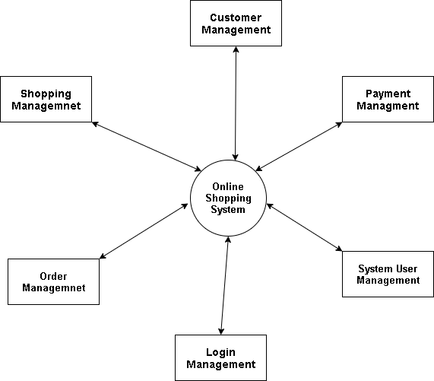

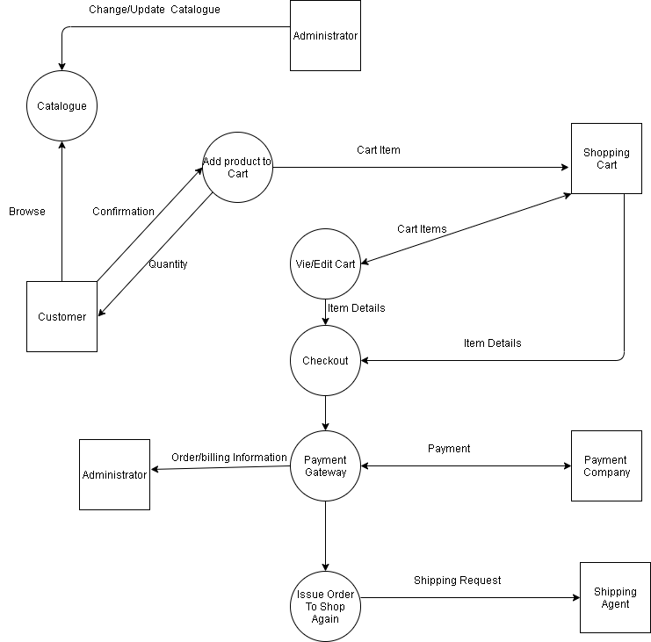

User Case Diagram:

A use case diagram is used to represent the dynamic behavior of a system.

